Week 2 Assignment
Scenario: A mid-size telecom operator currently has 5 independent data marts (Finance, Network, CRM, HR, Billing) with no central integration. You are the data architect tasked with evaluating the right architecture pattern.

Part A – Decision Matrix
Criteria | 2-Tier | 3-Tier | Reason
Scalability | 2/5 | 5/5 | 3-tier can handle more users and larger data
Data Consistency | 2/5 | 5/5 | Data is integrated and standardized before users access it
Development Effort | 4/5 | 2/5 | 2-tier is easier and faster to develop
Governance | 2/5 | 5/5 | 3-tier gives better control of data and security
Query Performance | 3/5 | 4/5 | The middle layer can prepare and optimize the data
TCO | 4/5 | 3/5 | 3-tier costs more at the beginning but is better for long-term use
Total | 17/30 | 24/30 | 3-tier is recommended
Part B – Architecture Diagram
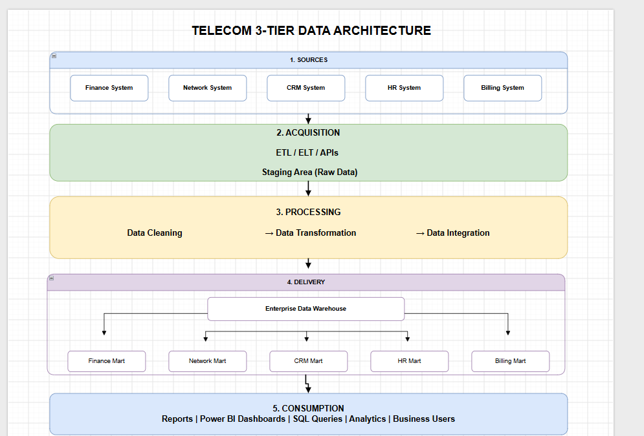
Part C – Layer Definitions
1. Sources
This layer contains the source systems such as Finance, Network, CRM, HR, and Billing. The data can come in different formats such as database tables, CSV files, or APIs.
2. Acquisition
This layer collects data from the different source systems using ETL, ELT, APIs, or batch loading. The data can be loaded into a staging area before processing.
3. Processing
In this layer, the data is cleaned, transformed, and integrated. For example, duplicate customer records can be removed and customer IDs can be standardized between CRM and Billing.
4. Delivery
The processed data is stored in the Enterprise Data Warehouse and then provided to the required data marts. This gives the company one consistent source of data.
5. Consumption
This is where business users access the data. They can use tools such as Power BI, reports, dashboards, or SQL queries for analysis and decision making.

Part D – Mart Integration

Mart | Location | Migration Strategy
Finance | Delivery Layer | Connect it to the central Data Warehouse and validate financial data
Network | Delivery Layer | Move network data gradually because it may contain large data volumes
CRM | Delivery Layer | Integrate customer data and create a common customer ID
HR | Delivery Layer | Migrate HR data with strong security and access control
Billing | Delivery Layer | Integrate billing data with CRM to connect customers with their payments

